# Data Structure and Algorithm Assignment

# RUSTAMJI INSTITUTE OF TECHNOLOGY

**BSF ACADEMY, TEKANPUR**

**Practical File for CS303 (Data Structure)**



Submitted by

NIKHIL B(0902cs231062)

B.Tech. Computer Science & Engineering 3rd Semester (2023-2027 batch)

Subject Teacher File Checked by

Dr. Jagdish Makhijani Mr. Yashwant Pathak



# Self-Declaration Certificate

I, **Nikhil B** , hereby declare that I have completed the lab work of CS303 (Data Structure) at my own effort and understanding.

I affirm that the work submitted is my own, and I take full responsibility for its authenticity and originality.

Date: 19/12/2024

[NIKHIL B] [0902CS231062]

# ENVORIONMENT USED

**Hardware Configuration :** < LAPTOP-3CDBOK0P(64-bit OS, x64 processor) >

**C Compiler :** GCC Compiler

**User Interface : VS CODE**

# GROUP MEMBERS

**Member-1 :** Nikhil B & 0902cs231062 https://github.com/29N11/Data-Structures-and-Algorithms.git

**Member-2 :** Srashti Jain & 0902cs231117 <https://github.com/Srashti-1/Data-Structure-.git>

**Member-3 :** Kishan Kumar & 0902cs231051 https://github.com/0902kishan/Data-structure-and-algorithms-.git

**Member-4 :** Yogesh Patel & 0902cs231137 https://github.com/Yogesh02545/Data-Structure-.git

# TABLE OF CONTENTS

**Section-A (Linked List)**

|  |  |  |  |
| --- | --- | --- | --- |
| **S.**  **No.** | **Practical Description** | **Page Nos.** | **COs** |
| 1 | Implementation of Linked List using array. | 1-2 | CO-1 |
| 2 | Implementation of Linked List using Pointers. | 3 | CO-1 |
| 3 | Implementation of Doubly Linked List using Pointers. | 4-5 | CO-1 |
| 4 | Implementation of Circular Single Linked List using  Pointers. | 6-8 | CO-1 |
| 5 | Implementation of Circular Doubly Linked List using  Pointers. | 9-10 | CO-1 |

**Section-B (Stack)**

|  |  |  |  |
| --- | --- | --- | --- |
| **S.**  **No.** | **Practical Description** | **Page Nos.** | **COs** |
| 1 | Implementation of Stack using Array. | 11-12 | CO-2 |
| 2 | Implementation of Stack using Pointers. | 13-15 | CO-2 |
| 3 | Program for Tower of Hanoi using recursion. | 16 | CO-2 |
| 4 | Program to find out factorial of given number using  recursion. Also show the various states of stack using in this program. | 17 | CO-2 |

**Section-C (Queue)**

|  |  |  |  |
| --- | --- | --- | --- |
| **S.**  **No.** | **Practical Description** | **Page Nos.** | **COs** |
| 1 | Implementation of Queue using Array. | 18-19 | CO-2 |
| 2 | Implementation of Queue using Pointers. | 20-22 | CO-2 |
| 3 | Implementation of Circular Queue using Array. | 23-25 | CO-2 |

**Section-D (Trees & Graphs)**

|  |  |  |  |
| --- | --- | --- | --- |
| **S.**  **No.** | **Practical Description** | **Page Nos.** | **COs** |
| 1 | Implementation of Binary Search Tree. | 26-29 | CO-3 |
| 2 | Conversion of BST PreOrder/PostOrder/InOrder. | 30-33 | CO-3 |
| 3 | Implementation of Kruskal Algorithm | 34-37 | CO-4 |
| 4 | Implementation of Prim Algorithm | 38-39 | CO-4 |
| 5 | Implementation of Dijkstra Algorithm | 40-41 | CO-4 |

**Section-E (Sorting & Searching)**

|  |  |  |  |
| --- | --- | --- | --- |
| **S.**  **No.** | **Practical Description** | **Page Nos.** | **COs** |
| 1 | Implementation of Sorting   1. Bubble 2. Selection 3. Insertion 4. Quick 5. Merge | 42-48 | CO-5 |
| 2 | Implementation of Binary Search on a list of numbers  stored in an Array | 49-50 | CO-5 |
| 3 | Implementation of Binary Search on a list of strings  stored in an Array | 51-52 | CO-5 |
| 4 | Implementation of Linear Search on a list of strings stored in an Array  OR  Implementation of Binary Search on a list of strings stored in a Single Linked List | 53-55 | CO-5 |

**Section(A)-Linkedlist**

**Experiment 1**

1. **Implementation of Linked list using array:**

#include <iostream>

using namespace std;

struct Node {

    int data;

    Node* next;

    Node(int d)

    {

        data = d;

        next = NULL;

    }

};

// Function to insert node at the end

Node* insertEnd(Node* root, int item)

{

    Node* temp = new Node(item);

    if (root == NULL)

        return temp;

    Node* last = root;

    while (last->next != NULL) {

        last = last->next;

    }

    last->next = temp;

    return root;

}

Node* arrayToList(int arr[], int n)

{

    Node* root = NULL;

    for (int i = 0; i < n; i++) {

        root = insertEnd(root, arr[i]);

    }

    return root;

}

void display(Node* root)

{

    while (root != NULL) {

        cout << root->data << " ";

        root = root->next;

    }

}

// Driver code

int main()

{

    int arr[] = { 1, 2, 3, 4, 5 };

    int n = sizeof(arr) / sizeof(arr[0]);

    Node* root = arrayToList(arr, n);

    display(root);

    return 0;

}

**Output:**

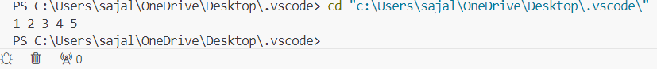

1. **Implementation of Linked list using pointer:**

#include <iostream>

using namespace std;

class node{

public:

    int data;

    node* next;

    node(int val){

    data=val;

    next=NULL;

  }

};

void insertAtTail(node* &head,int val){

node* n=new node(val);

if(head==NULL){

    return;

}

node* temp=head;

while(temp->next!=NULL)

{

  temp=temp->next;

}

temp->next=n;

}

void print(node* head){

node* temp = head;

while(temp!=NULL){

    cout<<temp->data<<" " ;

    temp=temp->next;

}

}

int main(){

    node*head = new node(1);

    insertAtTail(head,2);

    insertAtTail(head,3);

    insertAtTail(head,4);

    print(head);

    return 0;

}

**Output:**

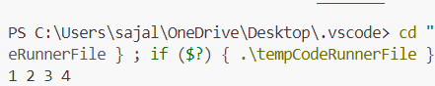

1. **Implementation of doubly-linkedlist using pointer:**

#include <iostream>

using namespace std;

class node

{

public:

    int data;

    node *next;

    node *prev;

    node(int x)

    {

        data = x;

        prev = NULL;

        next = NULL;

    }

};

void print(node *head)

{

    node *temp = head;

    while (temp != NULL)

    {

        cout << temp->data << " ";

        temp = temp->next;

    }

}

void insertatlast(node *head, int value)

{

    node *p = new node(value);

    node *temp = head;

    while (temp->next != NULL)

    {

        temp = temp->next;

    }

    temp->next = p;

    p->prev = temp;

    temp = p;

}

void insertathead(node *&head, int val)

{

    node *p = new node(val);

    p->next = head;

    head->prev = p;

    head = p;

}

void insertatindex(node *&head, int val, int index)

{

    node *p = head;

    node *node1 = new node(val);

    int i = 0;

    while (i < index - 1)

    {

        p = p->next;

        i++;

    }

    node1->next = p->next;

    p->next->prev = node1;

    p->next = node1;

    node1->prev = p;

}

int main()

{ node *head = new node(12);

    node *temp1 = new node(14);

    node *temp2 = new node(16);

    node *temp3 = new node(18);

    node *temp4 = new node(20);

    head->next = temp1;

    temp1->next = temp2;

    temp2->next = temp3;

    temp3->next = temp4;

    temp4->next = NULL;

    print(head);

    cout << endl;

    insertathead(head, 24);

    cout << "linkedlist after insertion " << endl;

    insertatlast(head, 50);

cout << "linkedlist after insertion " << endl;

    print(head);

    insertatindex(head, 15, 2);

cout << "linkedlist after insertion " << endl;

print(head);

    return 0;

}

**Output:**

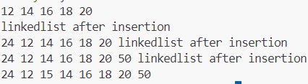

1. **Implementation of doubly-linkedlist using array:**

#include<bits/stdc++.h>

using namespace std;

// Doubly linked list node

struct node

{

    int data;

    struct node *next;

    struct node *prev;

};

// Utility function to create a node in memory

struct node* getNode()

{

    return ((struct node *)malloc(sizeof(struct node)));

}

// Function to display the list

int displayList(struct node *temp)

{

    struct node *t = temp;

    if(temp == NULL)

        return 0;

    else

    {

        cout<<"The list is: ";

        while(temp->next != t)

        {

            cout<<temp->data<<" ";

            temp = temp->next;

        }

        cout<<temp->data;

        return 1;

    }

}

// Function to convert array into list

void createList(int arr[], int n, struct node **start)

{

    // Declare newNode and temporary pointer

    struct node *newNode,*temp;

    int i;

    // Iterate the loop until array length

    for(i=0;i<n;i++)

    {

        // Create new node

        newNode = getNode();

        // Assign the array data

        newNode->data = arr[i];

        // If it is first element

        // Put that node prev and next as start

        // as it is circular

        if(i==0)

        {

            *start = newNode;

            newNode->prev = *start;

            newNode->next = *start;

        }

        else

        {

            // Find the last node

            temp = (*start)->prev;

            // Add the last node to make them

            // in circular fashion

            temp->next = newNode;

            newNode->next = *start;

            newNode->prev = temp;

            temp = *start;

            temp->prev = newNode;

        }

    }

}

// Driver Code

int main()

{

    // Array to be converted

    int arr[] = {1,2,3,4,5};

    int n = sizeof(arr) / sizeof(arr[0]);

    // Start Pointer

    struct node *start = NULL;

    // Create the List

    createList(arr, n, &start);

    // Display the list

    displayList(start);

    return 0;

}

**Output:**

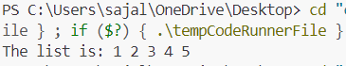

1. **Implementation of circular-linkedlist using pointer:**

#include <iostream>

using namespace std;

class node

{

public:

    int data;

    node *next;

    node(int val)

    {

        this->data = val;

        this->next = NULL;

    }

    ~node()

    {

        int value = this->data;

        if (this->next != NULL)

        {

            delete next;

            next = NULL;

        }

    }

};

// creation of circular linkedlist

void insertatnode(node *&tail, int index, int el)

{

    if (tail == NULL)

    {

        node *newNode = new node(el);

        tail = newNode;

        newNode->next = newNode;

    }

    else

    {

        node *temp = tail;

        while (temp->next != tail)

        {

            temp = temp->next;

        }

        node *curr = new node(el);

        curr->next = temp->next;

        temp->next = curr;

    }

}

//traversing linkedlist

void print(node *tail)

{

    node *temp = tail;

    do

    {

        cout << tail->data << " ";

        tail = tail->next;

    } while (tail != temp);

    cout << endl;

}

int main()

{

    node *tail = NULL;

    insertatnode(tail, 5, 3);

    print(tail);

    insertatnode(tail, 3, 4);

    print(tail);

    insertatnode(tail, 4, 9);

    print(tail);

    insertatnode(tail, 9, 7);

    print(tail);

    insertatnode(tail, 4, 5);

    print(tail);

return 0;

}

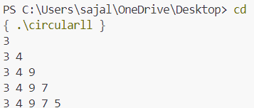 **Output:**

**Section(B)-STACK**

**Experiment 2**

1. **Implementation of stack using array:**

#include <iostream>

#include <stack>

using namespace std;

class Stack

{

public:

    int *arr, top, n;

    bool isEmpty();

    int size();

    //where n is the size of the array

    Stack(int x)

    {

        n = x;

        arr = new int[x];

        top = -1;

    }

    Stack(){}

    // function to push the element in an stack

    void push(int element)

    {

        if (n- top > 1)

        {

            top++;

            arr[top] = element;

        }

        else

        {

            cout << "overflow condition " << endl;

        }

    }

    void pop(){

        if(top>=0){

            top--;

        }

        else{

            cout<<"underflow condition "<<endl;

        }

    }

    //display the top element of the stack

    int peek(){

        if(top>=0){

            return arr[top];

        }

        else{

            cout<<"stack is empty "<<endl;

        }

    }

};

int main()

{

    class Stack st(5);

    st.push(1);

    cout << "The element at top is : "<< st.peek() << endl;

    st.push(2);

    cout << "The element at top is : "<< st.peek() << endl;

    st.push(3);

    cout << "The element at top is : "<< st.peek() << endl;

    st.push(4);

    cout << "The element at top is : "<< st.peek() << endl;

    st.push(5);

    cout << "The element at top is : "<< st.peek() << endl;

    st.pop();

    st.pop();

    cout<<"after popping of an element the element at top is : "<< st.peek() << endl;

    return 0;

}

**Output:**

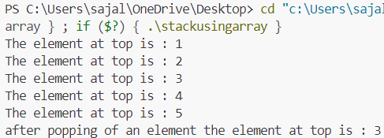

**2. Implementation of stack using pointer:**

#include <bits/stdc++.h>

using namespace std;

// Class representing a node in the linked list

class Node {

public:

    int data;

    Node* next;

    Node(int new_data) {

        this->data = new_data;

        this->next = nullptr;

    }

};

// Class to implement stack using a singly linked list

class Stack {

    // head of the linked list

    Node* head;

public:

    // Constructor to initialize the stack

    Stack() { this->head = nullptr; }

    // Function to check if the stack is empty

    bool isEmpty() {

        // If head is nullptr, the stack is empty

        return head == nullptr;

    }

    // Function to push an element onto the stack

  void push(int new_data) {

        // Create a new node with given data

        Node* new_node = new Node(new_data);

        // Check if memory allocation for the new node

        // failed

        if (!new_node) {

            cout << "\nStack Overflow";

        }

        // Link the new node to the current top node

        new_node->next = head;

      // Update the top to the new node

head = new_node;

    }

    // Function to remove the top element from the stack

    void pop() {

        // Check for stack underflow

        if (this->isEmpty()) {

            cout << "\nStack Underflow" << endl;

        }

        else {

            // Assign the current top to a temporary

            // variable

            Node* temp = head;

            // Update the top to the next node

            head = head->next;

            // Deallocate the memory of the old top node

            delete temp;

        }

    }

    // Function to return the top element of the stack

    int peek() {

      // If stack is not empty, return the top element

        if (!isEmpty())

            return head->data;

        else {

            cout << "\nStack is empty";

            return INT_MIN;

        }

    }

};

// Driver program to test the stack implementation

int main() {

    // Creating a stack

    Stack st;

    // Push elements onto the stac

    st.push(11);

    st.push(22);

    st.push(33);

    st.push(44);

    // Print top element of the stack

    cout << "Top element is " << st.peek() << endl;

    // removing two elemements from the top

      cout << "Removing two elements..." << endl;

    st.pop();

    st.pop();

    // Print top element of the stack

    cout << "Top element is " << st.peek() << endl;

    return 0;

}

**Output:**

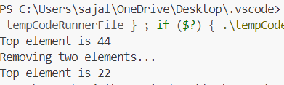

**3. Program of Tower of Hanoi using recursion:**

#include <bits/stdc++.h>

using namespace std;

void towerOfHanoi(int n, char from_rod, char to_rod,

                  char aux_rod)

{

    if (n == 0) {

        return;

    }

    towerOfHanoi(n - 1, from_rod, aux_rod, to_rod);

    cout << "Move disk " << n << " from rod " << from_rod

         << " to rod " << to_rod << endl;

    towerOfHanoi(n - 1, aux_rod, to_rod, from_rod);

}

// Driver code

int main()

{

    int N = 3;

    // A, B and C are names of rods

    towerOfHanoi(N, 'A', 'C', 'B');

    return 0;

}

**Output:**

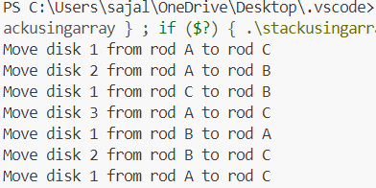

**4. Program to find out factorial using recursion. Also find the various state of stack during programs.**

#include <iostream>

using namespace std;

// Define a function to calculate factorial

// recursively

long long factorial(int n)

{

    // Base case - If n is 0 or 1, return 1

    if (n == 0 || n == 1) {

        return 1;

    }

    // Recursive case - Return n multiplied by

    // factorial of (n-1)

    return n * factorial(n - 1);

}

int main()

{

    int num = 5;

    // printing the factorial

    cout << "Factorial of " << num << " is "

         << factorial(num) << endl;

    return 0;

}

**Output:**



**Section(C)-QUEUE**

**Experiment-3**

**1. Implementation of queue using array:**

#include <iostream>

#define SIZE 5 // Define the maximum size of the queue

using namespace std;

class Queue {

private:

    int arr[SIZE]; // Array to store the queue

    int front;     // Index of the front element

    int rear;      // Index of the rear element

public:

    Queue() {

        front = -1;

        rear = -1;

    }

    // Function to check if the queue is empty

    bool isEmpty() {

        return (front == -1);

    }

    // Function to check if the queue is full

    bool isFull() {

        return (rear == SIZE - 1);

    }

    // Function to add an element to the queue

    void enqueue(int value) {

        if (isFull()) {

            cout << "Queue is full! Cannot enqueue " << value << endl;

            return;

        }

        if (isEmpty()) {

            front = 0; // Initialize front if queue was empty

        }

        arr[++rear] = value;

        cout << "Enqueued " << value << endl;

    }

    // Function to remove an element from the queue

    void dequeue() {

    if (isEmpty()) {

            cout << "Queue is empty! Cannot dequeue." << endl;

            return;

        }

        cout << "Dequeued " << arr[front] << endl;

        if (front == rear) {

            // Reset the queue when the last element is dequeued

            front = -1;

            rear = -1;

        } else {

            front++;

        }

    }

    // Function to display the elements in the queue

    void display() {

        if (isEmpty()) {

            cout << "Queue is empty!" << endl;

            return;

        }

        cout << "Queue elements: ";

        for (int i = front; i <= rear; i++) {

            cout << arr[i] << " ";

        }

        cout << endl;

    }

};

int main() {

    Queue q;

    q.enqueue(10);

    q.enqueue(20);

    q.enqueue(30);

    q.display();

    q.dequeue();

    q.display();

q.enqueue(40);

    q.enqueue(50);

    q.enqueue(60); // Attempt to enqueue beyond capacity

    q.display();

    return 0;

}

**Output:**

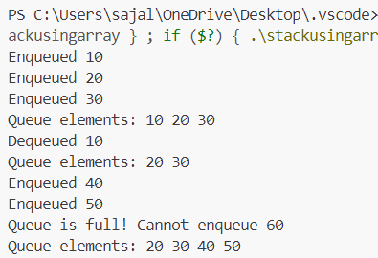

**2. Implementation of queue using pointers:**

#include <iostream>

using namespace std;

// Node structure for the queue

struct Node {

    int data;       // Value of the node

    Node* next;     // Pointer to the next node

    // Constructor to initialize a new node

    Node(int val) {

        data = val;

        next = nullptr;

    }

};

// Queue class

class Queue {

private:

    Node* front; // Pointer to the front node

    Node* rear;  // Pointer to the rear node

public:

    // Constructor to initialize the queue

    Queue() {

        front = nullptr;

        rear = nullptr;

    }

    // Function to check if the queue is empty

    bool isEmpty() {

        return front == nullptr;

    }

    // Function to add an element to the queue

    void enqueue(int value) {

        Node* newNode = new Node(value); // Create a new node

        if (isEmpty()) {

            // If the queue is empty, both front and rear point to the new node

            front = rear = newNode;

        } else {

            // Add the new node at the rear and update the rear pointer

            rear->next = newNode;

            rear = newNode;

        }

        cout << "Enqueued: " << value << endl;

    }

    // Function to remove an element from the queue

    void dequeue() {

        if (isEmpty()) {

            cout << "Queue is empty! Cannot dequeue." << endl;

            return;

        }

        Node* temp = front;       // Temporary pointer to the front node

        front = front->next;      // Move the front pointer to the next node

        cout << "Dequeued: " << temp->data << endl;

        delete temp;              // Delete the old front node

        if (front == nullptr) {

            // If the queue is empty after dequeue, reset rear to nullptr

            rear = nullptr;

        }

    }

    // Function to get the front element of the queue

    int peek() {

        if (isEmpty()) {

            cout << "Queue is empty!" << endl;

            return -1;

        }

        return front->data;

    }

    // Function to display the elements in the queue

    void display() {

        if (isEmpty()) {

            cout << "Queue is empty!" << endl;

            return;

        }

        Node* temp = front;

        cout << "Queue elements: ";

        while (temp != nullptr) {

            cout << temp->data << " ";

            temp = temp->next;

        }

        cout << endl;

    }

    // Destructor to free memory

    ~Queue() {

        while (!isEmpty()) {

            dequeue();

        }

    }

};

int main() {

    Queue q;

    q.enqueue(5);

    q.enqueue(15);

    q.enqueue(25);

    q.display();

    cout << "Front element: " << q.peek() << endl;

    q.dequeue();

    q.display();

    q.enqueue(35);

    q.enqueue(45);

    q.display();

    q.dequeue();

    q.dequeue();

    q.dequeue();

    q.dequeue(); // Attempt to dequeue when queue is empty

    return 0;

}

**Output:**

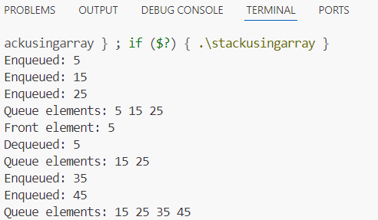

**3. Implementation of circular queue using array:**

#include <iostream>

using namespace std;

class CircularQueue {

private:

    int *queue;      // Pointer to dynamically allocated array

    int front;       // Index of the front element

    int rear;        // Index of the rear element

    int size;        // Maximum size of the queue

    int count;       // Current number of elements in the queue

public:

    // Constructor to initialize the circular queue

    CircularQueue(int maxSize) {

        size = maxSize;

        queue = new int[size];

        front = 0;

        rear = -1;

        count = 0;

    }

    // Destructor to clean up the allocated memory

    ~CircularQueue() {

        delete[] queue;

    }

    // Function to check if the queue is empty

    bool isEmpty() {

        return count == 0;

    }

    // Function to check if the queue is full

    bool isFull() {

        return count == size;

    }

    // Function to add an element to the queue

    void enqueue(int value) {

        if (isFull()) {

            cout << "Queue is full! Cannot enqueue " << value << "." << endl;

            return;

        }

        // Increment rear in a circular manner

        rear = (rear + 1) % size;

        queue[rear] = value;

        count++; // Increase the element count

        cout << "Enqueued: " << value << endl;

    }

    // Function to remove an element from the queue

    void dequeue() {

        if (isEmpty()) {

            cout << "Queue is empty! Cannot dequeue." << endl;

            return;

        }

        cout << "Dequeued: " << queue[front] << endl;

        // Move front forward in a circular manner

        front = (front + 1) % size;

        count--; // Decrease the element count

    }

    // Function to get the front element

    int getFront() {

        if (isEmpty()) {

            cout << "Queue is empty! No front element." << endl;

            return -1;

        }

        return queue[front];

    }

    // Function to get the rear element

    int getRear() {

        if (isEmpty()) {

            cout << "Queue is empty! No rear element." << endl;

            return -1;

        }

        return queue[rear];

    }

    // Function to display the elements of the queue

    void display() {

        if (isEmpty()) {

            cout << "Queue is empty!" << endl;

            return;

        }

        cout << "Queue elements: ";

        for (int i = 0; i < count; i++) {

            int index = (front + i) % size; // Calculate the current index

            cout << queue[index] << " ";

        }

        cout << endl;

    }

};

int main() {

    CircularQueue cq(5); // Create a circular queue with size 5

    cq.enqueue(10);

    cq.enqueue(20);

    cq.enqueue(30);

    cq.enqueue(40);

    cq.enqueue(50);

    cq.display();

    cq.dequeue();

    cq.dequeue();

    cq.display();

    cq.enqueue(60);

    cq.enqueue(70);

    cq.display();

    cout << "Front element: " << cq.getFront() << endl;

    cout << "Rear element: " << cq.getRear() << endl;

    cq.dequeue();

    cq.display();

    return 0;

}

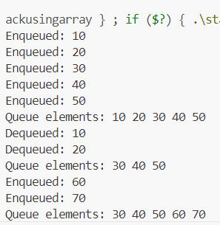**Output:**

**Section -D(trees and graph)**

**Experiment 4**

**1. Implementing of binary search tree**

#include <iostream>

using namespace std;

// Node structure for a Binary Search Tree

struct Node {

    int data;

    Node* left;

    Node* right;

};

// Function to create a new Node

Node* createNode(int data)

{

    Node* newNode = new Node();

    newNode->data = data;

    newNode->left = newNode->right = nullptr;

    return newNode;

}

// Function to insert a node in the BST

Node* insertNode(Node* root, int data)

{

    if (root == nullptr) { // If the tree is empty, return a

                           // new node

        return createNode(data);

    }

    // Otherwise, recur down the tree

    if (data < root->data) {

        root->left = insertNode(root->left, data);

    }

    else if (data > root->data) {

        root->right = insertNode(root->right, data);

    }

    // return the (unchanged) node pointer

    return root;

}

// Function to do inorder traversal of BST

void inorderTraversal(Node* root)

{

    if (root != nullptr) {

        inorderTraversal(root->left);

        cout << root->data << " ";

        inorderTraversal(root->right);

    }

}

// Function to search a given key in a given BST

Node* searchNode(Node* root, int key)

{

    // Base Cases: root is null or key is present at root

    if (root == nullptr || root->data == key) {

        return root;

    }

    // Key is greater than root's key

    if (root->data < key) {

        return searchNode(root->right, key);

    }

    // Key is smaller than root's key

    return searchNode(root->left, key);

}

// Function to find the inorder successor

Node* minValueNode(Node* node)

{

    Node* current = node;

    // loop down to find the leftmost leaf

    while (current && current->left != nullptr) {

        current = current->left;

    }

    return current;

}

// Function to delete a node

Node* deleteNode(Node* root, int data)

{

    if (root == nullptr)

        return root;

    // If the data to be deleted is smaller than the root's

    // data, then it lies in the left subtree

    if (data < root->data) {

        root->left = deleteNode(root->left, data);

    }

    // If the data to be deleted is greater than the root's

    // data, then it lies in the right subtree

    else if (data > root->data) {

        root->right = deleteNode(root->right, data);

    }

    // if data is same as root's data, then This is the node

    // to be deleted

    else {

        // node with only one child or no child

        if (root->left == nullptr) {

            Node* temp = root->right;

            delete root;

            return temp;

        }

        else if (root->right == nullptr) {

            Node* temp = root->left;

            delete root;

            return temp;

        }

        // node with two children: Get the inorder successor

        // (smallest in the right subtree)

        Node* temp = minValueNode(root->right);

        // Copy the inorder successor's content to this node

        root->data = temp->data;

        // Delete the inorder successor

        root->right = deleteNode(root->right, temp->data);

    }

    return root;

}

// Main function to demonstrate the operations of BST

int main()

{

    Node* root = nullptr;

    // create a BST

    root = insertNode(root, 50);

    root = insertNode(root, 30);

    root = insertNode(root, 20);

    root = insertNode(root, 40);

    root = insertNode(root, 70);

    root = insertNode(root, 60);

    root = insertNode(root, 80);

    // Print the inorder traversal of a BST

    cout << "Inorder traversal of the given Binary Search "

            "Tree is: ";

    inorderTraversal(root);

    cout << endl;

    // delete a node in BST

    root = deleteNode(root, 20);

    cout << "After deletion of 20: ";

    inorderTraversal(root);

    cout << endl;

    // Insert a node in BST

    root = insertNode(root, 25);

    cout << "After insertion of 25: ";

    inorderTraversal(root);

    cout << endl;

    // Search a key in BST

    Node* found = searchNode(root, 25);

    // check if the key is found or not

    if (found != nullptr) {

        cout << "Node 25 found in the BST." << endl;

    }

    else {

        cout << "Node 25 not found in the BST." << endl;

    }

    return 0;

}

**Output:**

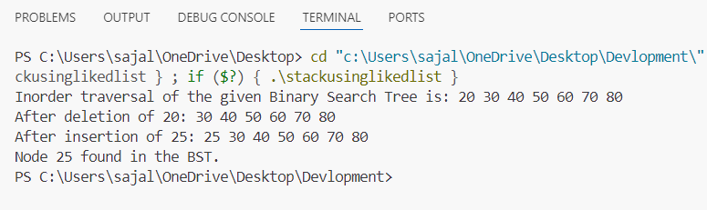

**2. implements of BST preorder/inorder/postorder**

**a) Preorder**

#include <bits/stdc++.h>

using namespace std;

// Class describing a node of tree

class Node {

public:

    int data;

    Node* left;

    Node* right;

    Node(int v)

    {

        this->data = v;

        this->left = this->right = NULL;

    }

};

// Preorder Traversal

void printPreOrder(Node* node)

{

    if (node == NULL)

        return;

    // Visit Node

    cout << node->data << " ";

    // Traverse left subtree

    printPreOrder(node->left);

    // Traverse right subtree

    printPreOrder(node->right);

}

// Driver code

int main()

{

    // Build the tree

    Node* root = new Node(100);

    root->left = new Node(20);

    root->right = new Node(200);

    root->left->left = new Node(10);

    root->left->right = new Node(30);

    root->right->left = new Node(150);

    root->right->right = new Node(300);

    // Function call

    cout << "Preorder Traversal: ";

    printPreOrder(root);

    return 0;

}

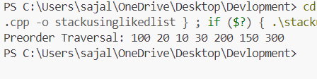**Output:**

**b) Postorder**

#include <bits/stdc++.h>

using namespace std;

// Class to define structure of a node

class Node {

public:

    int data;

    Node* left;

    Node* right;

    Node(int v)

    {

        this->data = v;

        this->left = this->right = NULL;

    }

};

// PostOrder Traversal

void printPostOrder(Node* node)

{

    if (node == NULL)

        return;

    // Traverse left subtree

    printPostOrder(node->left);

    // Traverse right subtree

    printPostOrder(node->right);

    // Visit node

    cout << node->data << " ";

}

// Driver code

int main()

{

    Node* root = new Node(100);

    root->left = new Node(20);

    root->right = new Node(200);

    root->left->left = new Node(10);

    root->left->right = new Node(30);

    root->right->left = new Node(150);

    root->right->right = new Node(300);

    // Function call

    cout << "PostOrder Traversal: ";

    printPostOrder(root);

    cout << "\n";

    return 0;

}

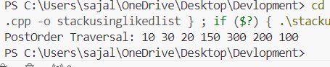**Output:**

**c) Inorder**

#include <bits/stdc++.h>

using namespace std;

// Class describing a node of tree

class Node {

public:

    int data;

    Node* left;

    Node* right;

    Node(int v)

    {

        this->data = v;

        this->left = this->right = NULL;

    }

};

// Inorder Traversal

void printInorder(Node* node)

{

    if (node == NULL)

        return;

    // Traverse left subtree

    printInorder(node->left);

    // Visit node

    cout << node->data << " ";

    // Traverse right subtree

    printInorder(node->right);

}

// Driver code

int main()

{

    // Build the tree

    Node* root = new Node(100);

    root->left = new Node(20);

    root->right = new Node(200);

    root->left->left = new Node(10);

    root->left->right = new Node(30);

    root->right->left = new Node(150);

    root->right->right = new Node(300);

    // Function call

    cout << "Inorder Traversal: ";

    printInorder(root);

    return 0;

}

**Output:**

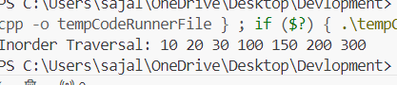

**3. Implementation of Kruskal Algorithm**

#include<bits/stdc++.h>

using namespace std;

// Creating shortcut for an integer pair

typedef pair<int, int> iPair;

// Structure to represent a graph

struct Graph

{

    int V, E;

    vector< pair<int, iPair> > edges;

    // Constructor

    Graph(int V, int E)

    {

        this->V = V;

        this->E = E;

    }

    // Utility function to add an edge

    void addEdge(int u, int v, int w)

    {

        edges.push_back({w, {u, v}});

    }

    // Function to find MST using Kruskal's

    // MST algorithm

    int kruskalMST();

};

// To represent Disjoint Sets

struct DisjointSets

{

    int *parent, *rnk;

    int n;

    // Constructor.

    DisjointSets(int n)

    {

        // Allocate memory

        this->n = n;

        parent = new int[n+1];

        rnk = new int[n+1];

        // Initially, all vertices are in

        // different sets and have rank 0.

        for (int i = 0; i <= n; i++)

        {

            rnk[i] = 0;

            //every element is parent of itself

            parent[i] = i;

        }

    }

    // Find the parent of a node 'u'

    // Path Compression

    int find(int u)

    {

        /* Make the parent of the nodes in the path

        from u--> parent[u] point to parent[u] */

        if (u != parent[u])

            parent[u] = find(parent[u]);

        return parent[u];

    }

    // Union by rank

    void merge(int x, int y)

    {

        x = find(x), y = find(y);

        /* Make tree with smaller height

        a subtree of the other tree */

        if (rnk[x] > rnk[y])

            parent[y] = x;

        else // If rnk[x] <= rnk[y]

            parent[x] = y;

        if (rnk[x] == rnk[y])

            rnk[y]++;

    }

};

/* Functions returns weight of the MST*/

int Graph::kruskalMST()

{

    int mst_wt = 0; // Initialize result

    // Sort edges in increasing order on basis of cost

    sort(edges.begin(), edges.end());

    // Create disjoint sets

    DisjointSets ds(V);

    // Iterate through all sorted edges

    vector< pair<int, iPair> >::iterator it;

    for (it=edges.begin(); it!=edges.end(); it++)

    {

        int u = it->second.first;

        int v = it->second.second;

        int set_u = ds.find(u);

        int set_v = ds.find(v);

        // Check if the selected edge is creating

        // a cycle or not (Cycle is created if u

        // and v belong to same set)

        if (set_u != set_v)

        {

            // Current edge will be in the MST

            // so print it

            cout << u << " - " << v << endl;

            // Update MST weight

            mst_wt += it->first;

            // Merge two sets

            ds.merge(set_u, set_v);

        }

    }

    return mst_wt;

}

// Driver program to test above functions

int main()

{

    /* Let us create above shown weighted

    and undirected graph */

    int V = 9, E = 14;

    Graph g(V, E);

    // making above shown graph

    g.addEdge(0, 1, 4);

    g.addEdge(0, 7, 8);

    g.addEdge(1, 2, 8);

    g.addEdge(1, 7, 11);

    g.addEdge(2, 3, 7);

    g.addEdge(2, 8, 2);

    g.addEdge(2, 5, 4);

    g.addEdge(3, 4, 9);

    g.addEdge(3, 5, 14);

    g.addEdge(4, 5, 10);

    g.addEdge(5, 6, 2);

    g.addEdge(6, 7, 1);

    g.addEdge(6, 8, 6);

    g.addEdge(7, 8, 7);

    cout << "Edges of MST are \n";

    int mst_wt = g.kruskalMST();

    cout << "\nWeight of MST is " << mst_wt;

    return 0;

}

**Output:**

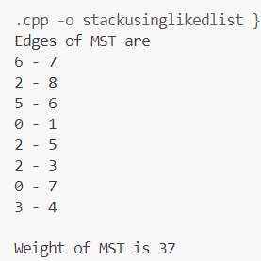

**4. Implementation of Prim Algorithm**

#include <bits/stdc++.h>

using namespace std;

// Function to construct and print the MST

void primMST(vector<vector<int>> graph) {

    int v = graph.size();

    // vector to store the parent of vertex

    vector<int> parent(v);

    // vector holds the weight/ cost of the MST

    vector<int> key(v);

    // vector to represent the set of

    // vertices included in MST

    vector<bool> vis(v);

    priority_queue<pair<int, int>,

    vector<pair<int, int>>,

    greater<pair<int, int>>> pq;

    // Initialize all key vector as INFINITE

    // and vis vector as false

    for (int i = 0; i < v; i++) {

        key[i] = INT_MAX;

        vis[i] = false;

    }

    // Always include the first vertex in MST.

    // Make key 0 so that this vertex is

    // picked as the first vertex.

    key[0] = 0;

    // First node is always the root of MST

    parent[0] = -1;

    // Push the source vertex to the min-heap

    pq.push({0, 0});

    while (!pq.empty()) {

        int node = pq.top().second;

        pq.pop();

        vis[node] = true;

        for (int i = 0; i < v; i++) {

            // If the vertex is not visited

            // and the edge weight of neighbouring

            // vertex is less than key value of

            // neighbouring vertex then update it.

            if (!vis[i] && graph[node][i] != 0

                && graph[node][i] < key[i]) {

                pq.push({graph[node][i], i});

                key[i] = graph[node][i];

                parent[i] = node;

            }

        }

    }

    // Print the edges and their

    // weights in the MST

    cout << "Edge \tWeight\n";

    for (int i = 1; i < v; i++) {

        cout << parent[i] << " - " << i

          << " \t" << graph[i][parent[i]] << " \n";

    }

}

int main() {

    // Define the adjacency matrix

  vector<vector<int>> graph = {{0, 2, 0, 6, 0},

                              {2, 0, 3, 8, 5},

                              {0, 3, 0, 0, 7},

                              {6, 8, 0, 0, 9},

                              {0, 5, 7, 9, 0}};

    // Find and print the Minimum Spanning

    // Tree using Prim's algorithm

    primMST(graph);

    return 0;

}

**Output:**

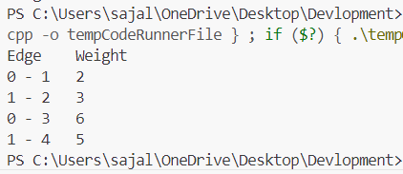

**5. Implementation of Dijkstra Algorithm**

#include <iostream>

#include <vector>

#include <queue>

#include <climits>

using namespace std;

typedef pair<int, int> pii; // Pair to store (distance, node)

void dijkstra(int start, vector<vector<pii>>& graph, vector<int>& distances) {

    priority_queue<pii, vector<pii>, greater<pii>> pq; // Min-heap priority queue

    pq.push({0, start});

    distances[start] = 0;

    while (!pq.empty()) {

        int currentDistance = pq.top().first;

        int currentNode = pq.top().second;

        pq.pop();

        // Skip if the distance is outdated

        if (currentDistance > distances[currentNode]) continue;

        // Explore neighbors

        for (auto& neighbor : graph[currentNode]) {

            int neighborNode = neighbor.first;

            int edgeWeight = neighbor.second;

            // Relaxation step

            if (distances[currentNode] + edgeWeight < distances[neighborNode]) {

                distances[neighborNode] = distances[currentNode] + edgeWeight;

                pq.push({distances[neighborNode], neighborNode});

            }

        }

    }

}

int main() {

    int n, m; // Number of nodes and edges

    cout << "Enter the number of nodes and edges: ";

    cin >> n >> m;

    vector<vector<pii>> graph(n + 1); // Adjacency list (1-based indexing)

    cout << "Enter the edges (u v w) where u and v are nodes and w is the weight:\n";

    for (int i = 0; i < m; ++i) {

        int u, v, w;

        cin >> u >> v >> w;

        graph[u].push_back({v, w});

        graph[v].push_back({u, w}); // For undirected graph; omit this for directed

    }

    int start;

    cout << "Enter the start node: ";

    cin >> start;

    vector<int> distances(n + 1, INT_MAX); // Initialize distances to infinity

    dijkstra(start, graph, distances);

    cout << "Shortest distances from node " << start << ":\n";

    for (int i = 1; i <= n; ++i) {

        if (distances[i] == INT_MAX) {

            cout << "Node " << i << ": INF\n";

        } else {

            cout << "Node " << i << ": " << distances[i] << "\n";

        }

    }

    return 0;

}

**Output:**

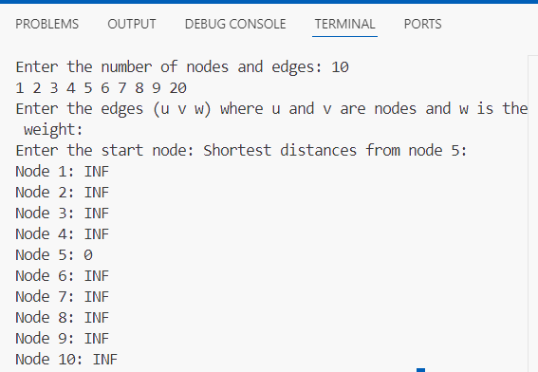

**Section-E(sorting and searching)**

**Experiment 1**

**1. Implementation of sorting**

**a. Bubble Sort**

#include <iostream>

using namespace std;

void bubbleSort(int arr[], int n) {

    // Traverse through all array elements

    for (int i = 0; i < n-1; i++) {

        // Flag to check if any swapping happens in the inner loop

        bool swapped = false;

        // Last i elements are already sorted, so we reduce the range

        for (int j = 0; j < n-i-1; j++) {

            // If the element is greater than the next element, swap them

            if (arr[j] > arr[j+1]) {

                // Swap arr[j] and arr[j+1]

                int temp = arr[j];

                arr[j] = arr[j+1];

                arr[j+1] = temp;

                swapped = true;

            }

        }

        // If no two elements were swapped by inner loop, then the array is already sorted

        if (!swapped) {

            break;

        }

    }

}

// Function to print the array

void printArray(int arr[], int n) {

    for (int i = 0; i < n; i++) {

        cout << arr[i] << " ";

    }

    cout << endl;

}

int main() {

    int arr[] = {64, 34, 25, 12, 22, 11, 90};

    int n = sizeof(arr)/sizeof(arr[0]);

    cout << "Unsorted array: ";

    printArray(arr, n);

    // Perform Bubble Sort

    bubbleSort(arr, n);

    cout << "Sorted array: ";

    printArray(arr, n);

    return 0;

}

**Output:**

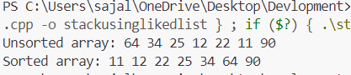

**b. Selection Sort**

#include <iostream>

using namespace std;

// Function to perform Selection Sort

void selectionSort(int arr[], int n) {

    // Traverse through all array elements

    for (int i = 0; i < n - 1; i++) {

        // Find the minimum element in the unsorted part of the array

        int min_idx = i;

        for (int j = i + 1; j < n; j++) {

            if (arr[j] < arr[min_idx]) {

                min_idx = j;

            }

        }

        // Swap the found minimum element with the first element of the unsorted part

        if (min_idx != i) {

            int temp = arr[i];

            arr[i] = arr[min_idx];

            arr[min_idx] = temp;

        }

    }

}

// Function to print the array

void printArray(int arr[], int n) {

    for (int i = 0; i < n; i++) {

        cout << arr[i] << " ";

    }

    cout << endl;

}

int main() {

    int arr[] = {64, 25, 12, 22, 11};

    int n = sizeof(arr) / sizeof(arr[0]);

    cout << "Unsorted array: ";

    printArray(arr, n);

    // Perform Selection Sort

    selectionSort(arr, n);

    cout << "Sorted array: ";

    printArray(arr, n);

    return 0;

}

**Output:**

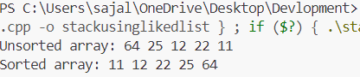

**c. Insertion**

#include <iostream>

#include <vector>

using namespace std;

void insertionSort(vector<int>& arr) {

    int n = arr.size();

    for (int i = 1; i < n; ++i) {

        int key = arr[i];

        int j = i - 1;

        // Move elements of arr[0..i-1] that are greater than key to one position ahead of their current position

        while (j >= 0 && arr[j] > key) {

            arr[j + 1] = arr[j];

            j = j - 1;

        }

        arr[j + 1] = key;

    }

}

int main() {

    int n;

    cout << "Enter the number of elements: ";

    cin >> n;

    vector<int> arr(n);

    cout << "Enter the elements: ";

    for (int i = 0; i < n; ++i) {

        cin >> arr[i];

    }

    insertionSort(arr);

    cout << "Sorted array: ";

    for (int i = 0; i < n; ++i) {

        cout << arr[i] << " ";

    }

    cout << endl;

    return 0;

}

**Output:**

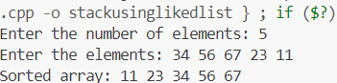

**d. Quick**

#include <iostream>

using namespace std;

// Function to partition the array into two halves based on the pivot

int partition(int arr[], int low, int high) {

    // Choose the rightmost element as the pivot

    int pivot = arr[high];

    // Pointer for the smaller element

    int i = (low - 1);

    // Traverse the array and rearrange elements based on the pivot

    for (int j = low; j < high; j++) {

        // If current element is smaller than or equal to the pivot, swap it

        if (arr[j] <= pivot) {

            i++;

            swap(arr[i], arr[j]);

        }

    }

    // Place the pivot element at its correct position in the array

    swap(arr[i + 1], arr[high]);

    return (i + 1);

}

// Function to perform Quick Sort

void quickSort(int arr[], int low, int high) {

    if (low < high) {

        // Partition the array into two halves and get the pivot index

        int pi = partition(arr, low, high);

        // Recursively sort the two halves

        quickSort(arr, low, pi - 1);  // Sort elements before the pivot

        quickSort(arr, pi + 1, high); // Sort elements after the pivot

    }

}

// Function to print the array

void printArray(int arr[], int n) {

    for (int i = 0; i < n; i++) {

        cout << arr[i] << " ";

    }

    cout << endl;

}

int main() {

    int arr[] = {10, 7, 8, 9, 1, 5};

    int n = sizeof(arr) / sizeof(arr[0]);

    cout << "Unsorted array: ";

    printArray(arr, n);

    // Perform Quick Sort

    quickSort(arr, 0, n - 1);

    cout << "Sorted array: ";

    printArray(arr, n);

    return 0;

}

**Output:**

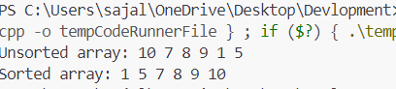

**e. merge sort**

#include <iostream>

#include <vector>

using namespace std;

void merge(vector<int>& arr, int left, int mid, int right) {

    int n1 = mid - left + 1;

    int n2 = right - mid;

    vector<int> L(n1), R(n2);

    for (int i = 0; i < n1; ++i)

        L[i] = arr[left + i];

    for (int j = 0; j < n2; ++j)

        R[j] = arr[mid + 1 + j];

    int i = 0, j = 0, k = left;

    while (i < n1 && j < n2) {

        if (L[i] <= R[j]) {

            arr[k] = L[i];

            i++;

        } else {

            arr[k] = R[j];

            j++;

        }

        k++;

    }

    while (i < n1) {

        arr[k] = L[i];

        i++;

        k++;

    }

    while (j < n2) {

        arr[k] = R[j];

        j++;

        k++;

    }

}

void mergeSort(vector<int>& arr, int left, int right) {

    if (left < right) {

        int mid = left + (right - left) / 2;

        mergeSort(arr, left, mid);

        mergeSort(arr, mid + 1, right);

        merge(arr, left, mid, right);

    }

}

int main() {

    int n;

    cout << "Enter the number of elements: ";

    cin >> n;

    vector<int> arr(n);

    cout << "Enter the elements: ";

    for (int i = 0; i < n; ++i) {

        cin >> arr[i];

    }

    mergeSort(arr, 0, n - 1);

    cout << "Sorted array: ";

    for (int i = 0; i < n; ++i) {

        cout << arr[i] << " ";

    }

    cout << endl;

    return 0;

}

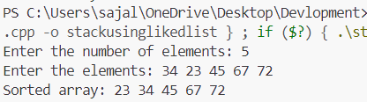**Output:**

**2. Implementation of Binary Search on a list of numbers stored in an Array**

#include <iostream>

using namespace std;

// Function to perform Binary Search

int binarySearch(int arr[], int size, int target) {

    int left = 0;

    int right = size - 1;

    // Loop until the search space is empty

    while (left <= right) {

        int mid = left + (right - left) / 2; // Find the middle element

        // Check if target is present at mid

        if (arr[mid] == target) {

            return mid; // Target found, return the index

        }

        // If target is greater, ignore the left half

        if (arr[mid] < target) {

            left = mid + 1;

        }

        // If target is smaller, ignore the right half

        else {

            right = mid - 1;

        }

    }

    // Target not found

    return -1;

}

int main() {

    // Example array (must be sorted for Binary Search)

    int arr[] = {1, 3, 5, 7, 9, 11, 13, 15, 17, 19};

    int size = sizeof(arr) / sizeof(arr[0]);

    int target;

    cout << "Enter the number to search for: ";

    cin >> target;

    // Perform Binary Search

    int result = binarySearch(arr, size, target);

    if (result != -1) {

        cout << "Element found at index " << result << endl;

    } else {

        cout << "Element not found!" << endl;

    }

    return 0;

}

**Output:**



**3. Implementation of Binary Search on a list of strings stored in an Array**

#include <iostream>

#include <string>

using namespace std;

// Function to perform Binary Search on a list of strings

int binarySearch(string arr[], int size, string target) {

    int left = 0;

    int right = size - 1;

    // Loop until the search space is empty

    while (left <= right) {

        int mid = left + (right - left) / 2; // Find the middle index

        // Check if the target is present at mid

        if (arr[mid] == target) {

            return mid; // Target found, return the index

        }

        // If target is greater, ignore the left half

        if (arr[mid] < target) {

            left = mid + 1;

        }

        // If target is smaller, ignore the right half

        else {

            right = mid - 1;

        }

    }

    // Target not found

    return -1;

}

int main() {

    // Example sorted array of strings

    string arr[] = {"apple", "banana", "cherry", "date", "grape", "kiwi", "mango", "orange", "pear", "watermelon"};

    int size = sizeof(arr) / sizeof(arr[0]);

    string target;

    cout << "Enter the string to search for: ";

    cin >> target;

    // Perform Binary Search

    int result = binarySearch(arr, size, target);

    if (result != -1) {

        cout << "Element found at index " << result << endl;

    } else {

        cout << "Element not found!" << endl;

    }

    return 0;

}

**Output**:

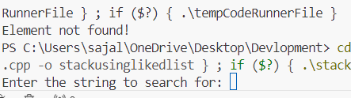

**4. Implementation of Linear Search on a list of strings stored in an Array**

#include <iostream>

#include <string>

using namespace std;

// Node structure for singly linked list

struct Node {

    string data;

    Node* next;

    Node(string value) {

        data = value;

        next = nullptr;

    }

};

// Function to add a node to the linked list

void append(Node*& head, const string& value) {

    Node* newNode = new Node(value);

    if (!head) {

        head = newNode;

    } else {

        Node* temp = head;

        while (temp->next) {

            temp = temp->next;

        }

        temp->next = newNode;

    }

}

// Function to find the middle node using slow and fast pointers

Node* findMiddle(Node* left, Node* right) {

    if (!left) return nullptr;

    Node* slow = left;

    Node* fast = left;

    while (fast != right && fast->next != right) {

        slow = slow->next;

        fast = fast->next->next;

    }

    return slow;

}

// Function to perform binary search on the linked list

Node* binarySearch(Node* head, const string& target) {

    if (!head) return nullptr;

    Node* left = head;

    Node* right = nullptr;

    while (left != right) {

        Node* mid = findMiddle(left, right);

        // Compare mid's data with the target

        if (mid->data == target) {

            return mid; // Target found

        }

        // If target is greater, search in the right half

        if (mid->data < target) {

            left = mid->next;

        }

        // If target is smaller, search in the left half

        else {

            right = mid;

        }

    }

    return nullptr; // Target not found

}

int main() {

    Node* head = nullptr;

    // Adding elements to the linked list

    append(head, "apple");

    append(head, "banana");

    append(head, "cherry");

    append(head, "date");

    append(head, "grape");

    append(head, "kiwi");

    append(head, "mango");

    append(head, "orange");

    append(head, "pear");

    append(head, "watermelon");

    string target;

    cout << "Enter the string to search for: ";

    cin >> target;

    // Perform binary search on the linked list

    Node* result = binarySearch(head, target);

    if (result != nullptr) {

        cout << "Element found: " << result->data << endl;

    } else {

        cout << "Element not found!" << endl;

    }

    return 0;

}

**Output:**

